Empirical Strategy
Draft Methods Section

Empirical Strategy Overview
To isolate the causal effect of social media sentiment on stock returns, I must first isolate the effect of social media sentiment from other endogenous factors that impact both social media sentiment and share price. After talking with professional traders, and consulting prior academic literature, I concluded that by controlling for factors used by traders to form opinions, as well as news sentiment, I could isolate the effect of social media alone using a fixed effects model with a binary treatment status to identify the causal effect. Section 1 outlines the data sources and the justifications for their selection. Section 2 specifies the fixed effects model to be used. Section 3 expands on the existing model, for which data currently exists, to include aspirational goals to access new data that would allow for further isolation of the specific impact of social media on share price.

1 Data

Data has been collected exclusively from Bloomberg. Previous studies have used this as a data source due to the volume and quality of the data. More importantly, Bloomberg is the most widely trusted source of information for both professional and amateur traders alike. This makes it the ideal place from which to draw information for a study that is, at its core, about how traders use information to price trades.

Furthermore, Bloomberg conducts daily sentiment analysis already, and because of a 2015 data licensing agreement, Bloomberg has enhanced access to posts than would be available with the current API. The platform also offers media sentiment analysis tools to which to compare Twitter sentiment. This is useful in that it allows me to control for the effect of the news media to isolate the effect of Twitter alone.

For this study, I have chosen to pull panel data covering a roughly two-year period for the S&P 500. These companies all have twitter accounts, and all are large enough to feature in the both social media and the traditional media. This makes them ideal candidates for study. Specific details of the data are listed below:

Date Range: Jan 1, 2024 – March 4, 2026 (Non-trading days excluded)

Specific categories selected:

Company Ticker

Opening Price

Closing Price

Highest Price

Lowest Price

Equity Weighted Volume: Average price throughout the day as weighed against total trading volume

Current Market Capitalization: Total market capitalization at the close of trading

30 Day Relative Strength Index (RSI): Used by traders to determine if a stock is over or under bought

50 Day Moving Average Price: Average price of the last 50 trading days. Used by traders to determine near to mid-term growth of the company.

Average Daily Twitter Sentiment: Average sentiment using Bloomberg’s tool U[-1,1]

Tweets Count: Count of the total number of tweets daily that reference a given company

Average Daily News Sentiment D-1: Average sentiment of news coverage from the day prior U[-1,1]

Given the dynamic nature of social media, the assumption is that it will quickly diffuse into the market impacting prices. To account for this, I am looking at the change in share price from the opening of trading till closing. This will be my dependent variable for the study.

To capture this variable, the change in price over a day of trading was imputed using the opening and closing prices. This was also done with lags of 1, 2, 3, 5, and 7 days, with the assumption being that shocks to price from social media would be short lived, but that larger systemic changes to a company would drive changes that are consistent across all time horizons, not just the short term.

2 Identification Strategy
The central identification challenge in estimating the effect of social media sentiment on stock prices is that sentiment is endogenous, and sentiment may reflect, rather than cause, stock price movement. To account for this I have elected to control for general media sentiment, as well as the Relative Strength Index and a moving 50-day average price, both of which are used by traders to evaluate the tradability of an asset. These allow me to put twitter sentiment outside the pre-trading decision making cycle, using it instead as an exogenous influence on trader behavior (measured in Equity Weighted Volume), and thus asset price because those assets in higher demand are worth more. The below Directed Acyclic Graph shows this relationship.
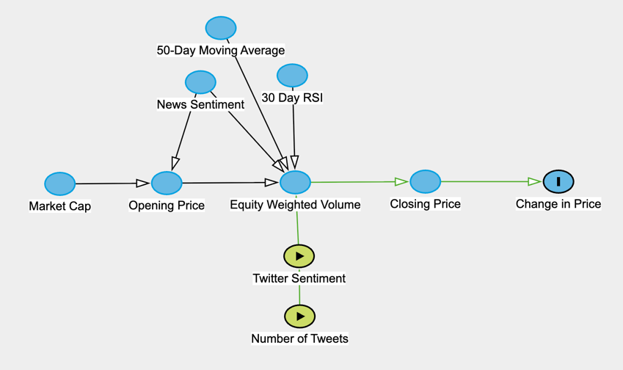

This representation implies that trader decisions will follow the parallel trends assumption and would have remained the same were it not for the intervention of negative tweets. Given that most traders will increase trading as a stock gets hot or cold in the buildup to trading, this assumption is likely to hold, and can be accounted for given the application of lags which allow for the return to be measured across time horizons that are generally in line with, or longer than, social media effects.
To estimate this model, I have chosen, fixed effects with binary treatment. By creating a control group of negative sentiment only, to serve as the treatment group (D_{i} = 1), I can further isolate the effect of sentiment. Because the remaining sample becomes a control group (D_{i} = 0), I can look specifically for a negative reaction to negative sentiment, allowing for greater isolation of the impact of social media. This will be evaluated through the following model:
r_{i,t} = α_{i} + β₁Sentiment_{i,t−k} + β₂D_{i} + β₃(Sentiment_{i,t−k} × D_{i}) + γ′X_{i,t} + ε_{i,t}
r_{i,t}: Daily return of firm i on day t (considering using log return)
α_{i}: Company-level fixed effects
Sentiment_{i,t−k}: Average daily Twitter sentiment for firm i on day t − k, where k ∈ {0, 1, 2, 3, 5, 7} lags
D_{i}: Treatment status (1 if social media sentiment is negative)
X_{i,t}: Vector of controls influencing trader behavior before trading
ε_{i,t}: Error term.
Here the parameter of interest is β_{3,} which represents the treatment effect of negative social media, while controlling for other influences on asset price. This approach is similar to Teti et al (2019), just using sentiment direction instead of volume of posts. The key testable implication is that the interaction between sentiment and the treatment dummy should be negative and significant: prices should drop when sentiment does.

3 Expanded Data Strategy
The availability of data on Bloomberg allows for extensive controls to be put into place to address Twitter sentiment and news sentiment. However, these are not the only sources from which traders draw their information, particularly so for amateur traders who are more likely to draw information from informal sources. However, this is where we run into the limitations of the Bloomberg Twitter Sentiment tools. Because they only draw from Twitter, they are confined to data shared on Twitter. And, because social media usage fluctuates by platform and demographic, users of Twitter are far fewer and farther between than other platforms, such as Instagram of TikTok.
Just as platforms are different, not all posters are created equal. A post from a titan of finance, such as Jamie Dimon, is likely to carry more weight than one from Mr. Beast. This too is unaccounted for in the Bloomberg tool. However, the ability to test not only specific platform effects but also those of individual users allows for a clear externality to be identified. This externality can be applied to observe the immediate causal effect of social media on asset pricing.
However, this will require me to build a new tool with which to evaluate social media. I would like to attempt this. If I am able to make it work reliably, similar to Cam et al (2023), I will be able to assess just posts in specific languages and from specific accounts. This will allow me to create a series of natural experiments through with to further isolate the causal effect of social media on share prices.

4 Threats to Identification
Concerns about the collinearity of stock performance and tweets are very fair in this study. To control for these, I have elected to specifically assign controls for those performance metrics that traders look at most often from sources like Bloomberg. (Market/asset-specialists use other business intelligence as well that are outside the scope of this study.). These allow me to treat tweets like an exogenous force acting on the traders during the trading day.
By further limiting scope to negative posts, I am able to also mitigate the effects of meme-stock trading, such as what happened with the GameStop short in 2021. Negative events can also occur, however, they are less common as investors are more apt to hold stocks through small downturns. Thus assigning treatment based on negative social media sentiment allows for better identification than looking either at sentiment more generally, or by volume of posts.
Lastly, to account for shocks effecting companies individually, I have chosen firm-level fixed effects to ensure that whatever endogenous factors influence that company’s share price, their twitter sentiment remains impactful to them alone, allowing for a more accurate overall representation of social media’s impact of asset pricing across the market.

